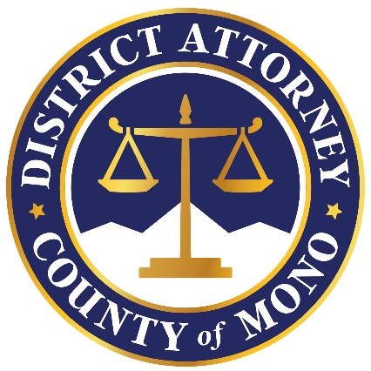
April 7, 2023

The Mono County District Attorney’s Office would like to remind homeowners and snow removal operations that price gouging during a declared emergency is illegal and will be prosecuted. Price gouging is a misdemeanor under Penal Code Section 396(b) and is punishable by up to one year in County jail and/or a fine of up to $10,000. Violators are also subject to civil enforcement actions including civil penalties of up to $2,500 per violation, injunctive relief, and mandatory restitution.
Penal Code Section 396 prohibits raising the price of many consumer goods and services by more than 10% after an emergency has been declared. For items or services a seller only began offering after an emergency is declared, the seller may not charge a price greater than 50% of what it cost the seller to provide the item or service.
“Mono County is a wonderful community where most people eagerly do whatever they can to help those in need; however, as residents and homeowners recover from this unrelenting winter, we will not tolerate anyone who attempts to unfairly and illegally profit from the misfortune of others,” said District Attorney David Anderson. If you believe you have been the victim of price gouging, please contact any of the following agencies below.

Mammoth Lakes Police Department Mono County Sheriff’s Department
(760) 965-3700 (760) 932-7549

Mono County District Attorney California Attorney General
(760) 924-1710 (800) 952-5225
Oag.ca.gov/report

