Free Two-Day Training
Mentally Ill Offender
Vicarious Trauma in Your World
Trauma Informed Care
Skills for Stress Management
May 18 - May 19, 2020
Mammoth Lakes Fire Department 3150 Main St
8:00 a.m. – 5:00 p.m. each day
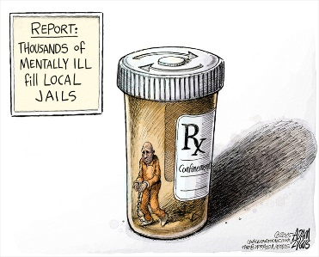
Mentally Ill Offender
Topics covered will include overview of psychological concepts, personality
development and mental illness, competence, legal tests, psychosis, case studies,
sanity and legal test, psychological issues, - and other types of mentally ill
offenders, treatment options for the mentally ill offender, and placement
options for the mentally ill offender.
Vicarious Trauma in Your World
This course will focus on understanding vicarious trauma and the emotional exposure
that can occur from hearing other people’s traumatic stories. The goal is to create
awareness for professionals working with traumatized people, caretakers often
self-neglect, try to emotionally tough it out, and deny their personal needs.

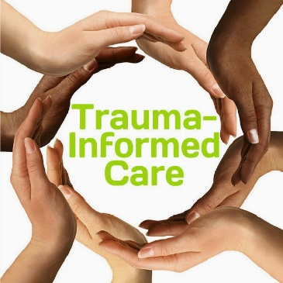
Trauma Informed Care

Trauma Informed Care enables the individual to assess their own emotional injuries,
while examining the connection between their childhood maltreatment, also called
Adverse Childhood Experiences (ACE) and gain a better understanding of how those
experiences directly shape one’s behavioral outcomes. While using a student-centered
techniques, students will learn real outcome-based strategies and how to best apply
trauma informed care. These self-assessment techniques are specifically designed
to empower the individual to move beyond their history of trauma.

Skills for Stress Management

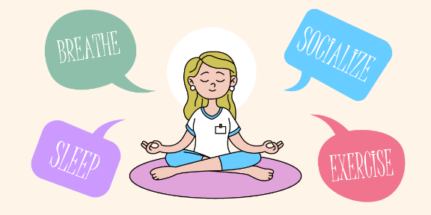
Combining modern scientific information on brain physiology and
ancient wisdom from eastern philosophies, this course will be an active
participation course on how to live a healthier, stress reduced life.
Benefits of utilizing these stress management skills by probation
officers can improve cognitive functioning, have fewer inter-personal
conflicts and better physical and psychological health.

RSVP or Questions contact: JAZMIN BARKLEY (760) 924-1764
jbarkley@mono.ca.gov

